**Topic:** Food Poisoning in Spanish Food in 2022 – Vigoursoul

**Focus keyword:** Food Poisoning in Spanish

**Meta Title:** Food Poisoning in Spanish in 2022 – Vigoursoul

**Meta Description:** Food poisoning is a disease induced by consuming tainted food. Learn about the signs and treatments of food poisoning.

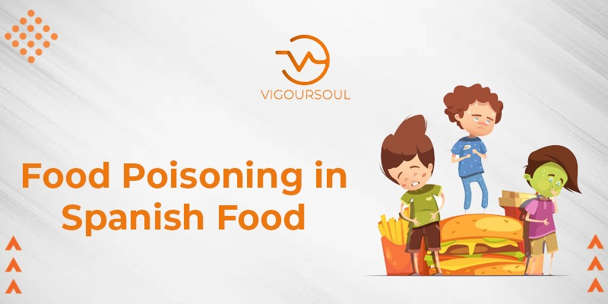

**Foodborne sickness**, sometimes known as food poisoning, is caused by consuming infected, damaged, or poisoned food. Nausea, vomiting, and diarrhea are the most frequent symptoms of food poisoning.

**Table of content:**

: **Food Poisoning Symptoms:**

Food poisoning is not uncommon, despite how unpleasant it is. According to the Centers for Disease Control and Prevention (CDC)Trusted Source, 48 million Americans (or roughly one out of every seven) get food poisoning each year. 128,000 of those 48 million people are hospitalized.

If you have food poisoning, it is unlikely that you will go unnoticed.

Depending on the source of the illness, symptoms may differ.

A few of the following symptoms are common in cases of food poisoning:

* Abdominal cramps
* Diarrhea
* Nausea
* Vomiting
* Loss of appetite
* Mild fever
* Weakness
* Headache

**Symptoms of potentially Fatal Food Poisoning Include:**

* Diarrhea that lasts for more than 3 days
* A fever higher than 102°F (38.9°C)
* Difficulty seeing or speaking
* Symptoms of severe dehydration , which may include dry mouth, passing little to no urine, and difficulty keeping fluids down
* **Bloody urine** if you see any of these symptoms, consult a doctor or seek medical attention.

**Causes of food poisoning:**

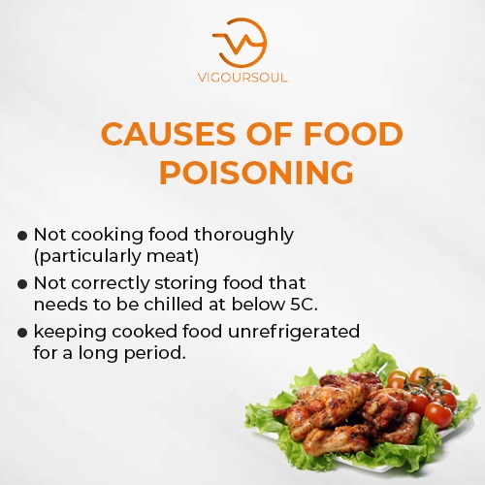

The majority of food poisoning is caused by one of three principal agents: bacteria, parasites, or viruses.

* These infections can be found on practically all foods consumed by humans. Heat from cooking, on the other hand, normally eliminates microorganisms on food before it reaches our plate. Because raw foods do not go through the cooking process, they are typical causes of food illness.
* Food will occasionally come into touch with microbes in faces or vomit. This is most likely to happen when an unwell person prepares food without washing their hands beforehand.
* Meat, eggs, and dairy products are often tainted. Water may potentially be polluted with pathogenic organisms.

**Types of Food Poisoning:**

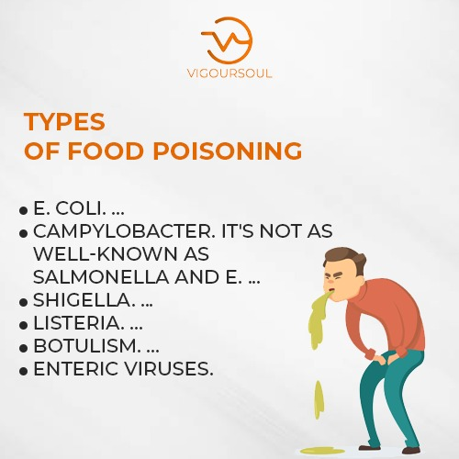

There are different types of food poisoning

**Bacteria:**

Bacteria, which are small organisms, can enter the GI system from contaminated food and cause symptoms such as nausea, vomiting, diarrhea, and stomach discomfort.

**Viruses:**

Virus-caused food sickness can also spread from person to person. Nor virus is a common foodborne virus that causes inflammation in the stomach and intestines.

**Parasites:**

Parasites are creatures of various sizes. Some are minuscule, but others, like parasitic worms, may be seen with the human eye. These creatures live in or on other species (referred to as hosts) and get nutrition from them.

**Food Poisoning Treatments:**

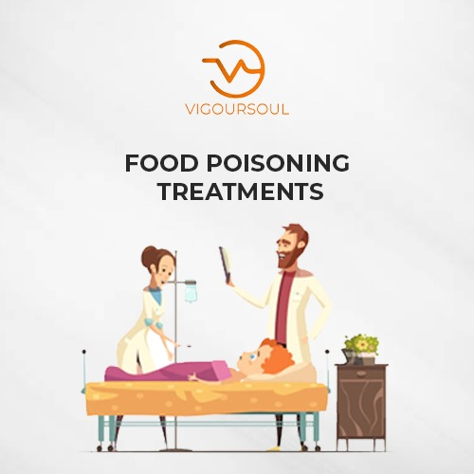

Food poisoning is frequently treatable at home. Here are some home remedies for food poisoning:

**Stay Hydrated:**

It is critical to stay hydrated if you have food illness. Electrolyte-rich sports beverages can be beneficial. Fruit juice and coconut water can help replenish carbs and alleviate weariness.

Caffeine, which can irritate the digestive tract, should be avoided. Decaffeinated teas containing calming herbs like chamomile, peppermint, and dandelion may help to soothe an upset stomach.

**Take over-the-counter (OTC) medications:**

OTC drugs such as lope amide (Imodium) and Pepto-Bismol can help you control your diarrhea and nausea.

However, you should see a doctor before using these treatments since the body utilizes vomiting and diarrhea to eliminate the poison. Furthermore, utilizing these drugs may conceal the severity of your sickness and drive you to delay getting professional help.

**Take Prescription Medications:**

Although many cases of food poisoning resolve on their own, depending on the organism responsible for their sickness, some patients may benefit from prescription drugs.

People who are elderly, immunocompromised, or pregnant may benefit from prescription drugs. Antibiotic medication during pregnancy aids in the prevention of infection transmission to the unborn child.

**Receive an Antitoxin:**

A C. botulin infection is considered a medical emergency. Seek medical attention as soon as possible.

If you have C. botulin, a doctor will give you an antitoxin. Babies will be given a special antitoxin known as Baby BIG.

**Rest:**

Those suffering from food poisoning should also get plenty of rest.

**Frequently asked questions:**

**How food poisoning is diagnosed?**

Based on your symptoms, a doctor may be able to determine the sort of food poisoning you have.

In extreme situations, blood tests, stool testing, and tests on the food you ate may be performed to discover what caused the food poisoning. A urine test may also be used by a doctor to determine whether you are dehydrated as a result of food poisoning.

**How do Harmful Chemicals Cause Food Poisoning?**

Certain foods may contain harmful substances, including

NIH external link fish and shellfish that contain toxins caused by algae or bacteria some species of wild mushrooms unwashed food that includes high levels of chemical pesticides.

**What is the Best Tablet for Food Poisoning?**

To treat diarrhea caused by food poisoning, adults can use over-the-counter medications such as lope amide link (Imodium) and bismuth subsalicylate link (Pepto-Bismol, Kaopectate).

**What can I Drink While Food Poisoning?**

You can either drink water or Gatorade or Pedialyte. You may be tempted to try over-the-counter treatments, but food poisoning, according to Dr. Feckoury, typically needs to run its course. Meanwhile, he recommends rest and the BRAT diet, which consists of bananas, rice, applesauce, and toast.

**Which Five Foods are Most Risky for Food Poisoning?**

Poultry, shellfish, deli meat, eggs, unpasteurized dairy, rice, fruits, and vegetables all pose a significant risk of food poisoning, particularly when improperly kept, prepared, or cooked.

Conclusion:

Food poisoning is prevalent, but recovery requires adequate medical treatment. If the sickness is ignored for an extended period of time, it can progress to major health problems that may necessitate protracted hospitalization for recovery.

https://www.youtube.com/watch?v=02j-23XWgu0